Date: Class: Name:
My Computing Progress - Programming |  | Not tried yet | A bit  ✓ | ✓✓✓
Teamwork   | I can work with a grown up to get things done.
 | I can work with a partner; we take turns, help each other and get things done.
 | I can teach my classmates to help them get things done.
Control and Simulation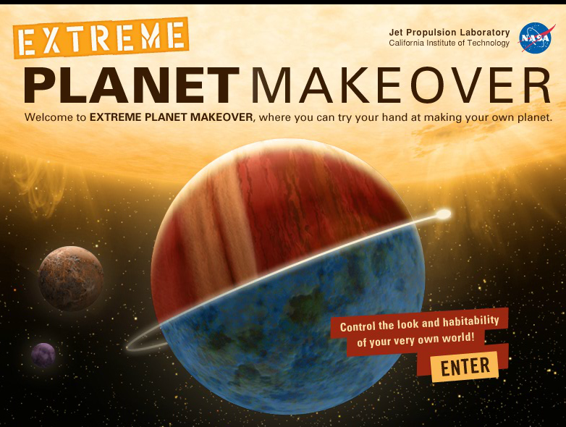 | I can control a toy or everyday device by giving 1 instruction at a time.
 | I can make choices to control an online simulation or game.
 | I can say what a simulation is and give an example.
Algorithms  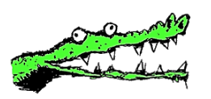  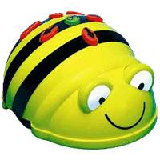  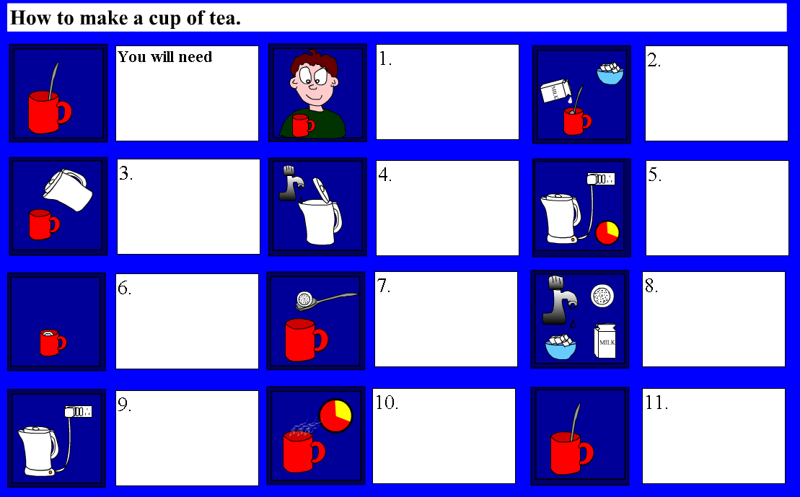  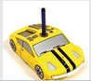   | I can use role play toys and do things in the right order e.g. like make a cup of tea and I can say this is an algorithm.
 | I can tell my friend to do something in the right order e.g. like get through a maze with a blind fold on and I can say this is an algorithm.
 | I can control a toy by programming a sequence of instructions and I understand that this is called an algorithm.
 | I can say what an algorithm is.
 | I can give an example of an algorithm.
 | I can say programs are algorithms working on computers.
 | I can draw a storyboard or the steps of an algorithm so someone else can understand it.
 | I can predict what someone else’s storyboard will make happen.
Tech Words | When I talk about my work I use ‘tech’ words like program, input, output, cursor, and file.
Using Tech   | I can say what computers are for at school or at home and I can say how I use them.
 | I can say some jobs that people do with computers.
Scratch Control   | I can click on a block to make something happen.
 | I can predict what a block will do.
 | I can change a number in a ‘move’ block to make a sprite move.
Scratch Programming  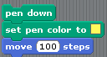 | I can snap blocks into a sequence to make something happen and solve a problem. (Create a program/algorithm).
 | I can predict what a sequence of blocks will do.
Bugs  | I can spot a bug and predict what will go wrong.
 | I can fix a bug and say how I fixed it.
More Programming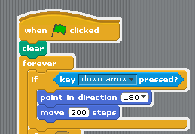 | I can use a selection such as a control block to give some kind of choice (branching) e.g. if key down pressed move down
 | I can use a repeat 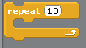block to make a program shorter.
Understanding data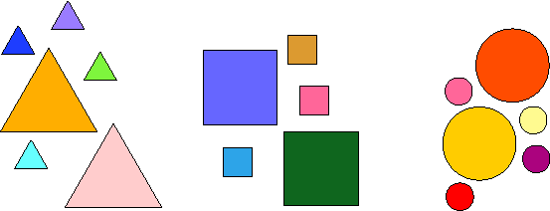 | I can sort objects into groups like by colour, size or type.
 | I can say there are different types of data like numbers, pictures or words.

I really enjoyed _____________________________________________________________________

I would like to do some more ____________________________________________________________

