KS1 Programming Progression Grid – through I can statements
First cut. J Waite 3/8/2013

Progression

Red is emerging – perhaps most seen by end of year 1
Green is expected – this is required by end of year 2 to achieve NC subject content objectives
Yellow is exceeding KS1 requirements

NC subject strand cross reference
Algorithm - understand what algorithms are; how they are implemented as programs on digital devices; and that programs execute by following precise and unambiguous instructions
Code - create and debug simple programs
Predict - use logical reasoning to predict the behaviour of simple programs
Common Use recognise common uses of information technology beyond school.
KS2 design - KS2 design, write and debug programs that accomplish specific goals, including controlling or simulating physical systems
KS2 Code - KS2 use sequence, selection, and repetition in programs; work with variables and various forms of input and output

My Computing Progress - Programming |  | Algorithm | Code | Predict | Common use | KS2 deign | KS2 code
Teamwork   | I can work with a grown up to get things done.
 | I can work with a partner; we take turns, help each other and get things done.
 | I can teach my classmates to help them get things done.
Control and Simulation | I can control a toy or everyday device by giving 1 instruction at a time. | X
 | I can make choices to control an online simulation or game. | X
 | I can say what a simulation is and give an example. | x
Algorithms  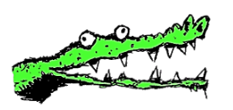  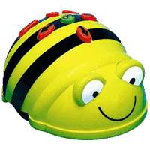  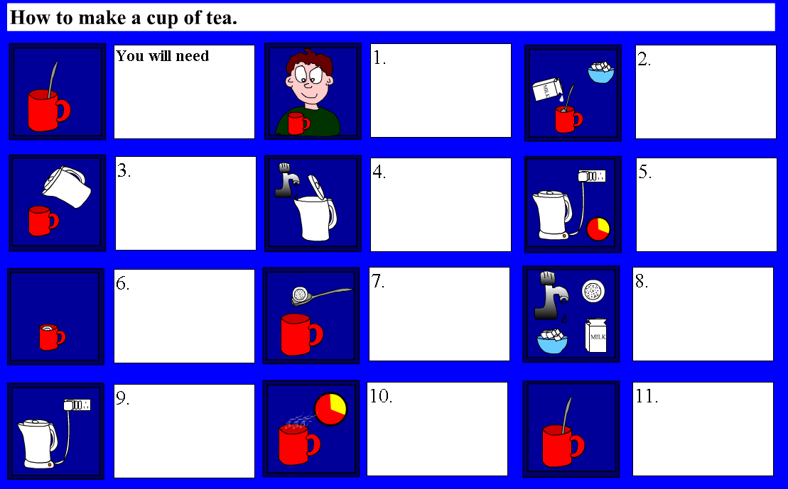  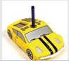   | I can use role play toys and do things in the right order e.g. like make a cup of tea and I can say this is an algorithm. | X
 | I can tell my friend to do something in the right order e.g. like get through a maze with a blind fold on and I can say this is an algorithm. | X
 | I can control a toy by programming a sequence of instructions and I understand that this is called an algorithm. | x
 | I can say what an algorithm is. | X
 | I can give an example of an algorithm. | X
 | I can say programs are algorithms working on computers. | X
 | I can draw a storyboard or the steps of an algorithm so someone else can understand it. | X |  |  |  | X
 | I can predict what someone else’s storyboard will make happen. | X |  | X |  | X
Tech Words | When I talk about my work I use ‘tech’ words like program, input, output, cursor, and file.
Using Tech   | I can say what computers are for at school or at home and I can say how I use them. |  |  |  | X
 | I can say some jobs that people do with computers. |  |  |  | X
Scratch Control   | I can click on a block to make something happen. |  | X
 | I can predict what a block will do. |  | X
 | I can change a number in a ‘move’ block to make a sprite move. |  | X
Scratch Programming  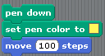 | I can snap blocks into a sequence to make something happen and solve a problem. (Create a program/algorithm). |  | X
 | I can predict what a sequence of blocks will do. |  | X | X
Bugs  | I can spot a bug and predict what will go wrong. |  | X | X
 | I can fix a bug and say how I fixed it. |  | X | X
More Programming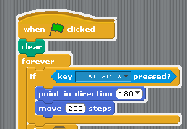 | I can use a selection such as a control block to give some kind of choice (branching) e.g. if key down pressed move down |  | X |  |  |  | X
 | I can use a repeat 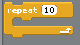block to make a program shorter. |  | X |  |  |  | X
Understanding data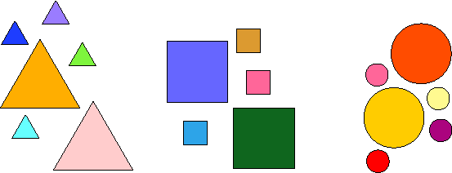 | I can sort objects into groups like by colour, size or type. |  | x
 | I can say there are different types of data like numbers, pictures or words. |  | X |  |  | X

