
Flood Alert activity sheet – Line graphs

Name: …………………………………. Date: ……………………

Discuss in groups each of the four graphs below.
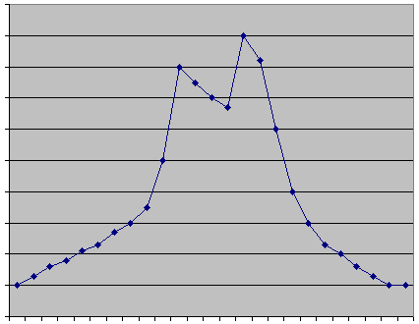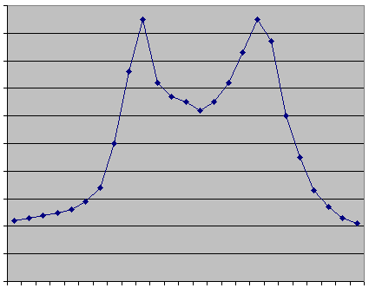

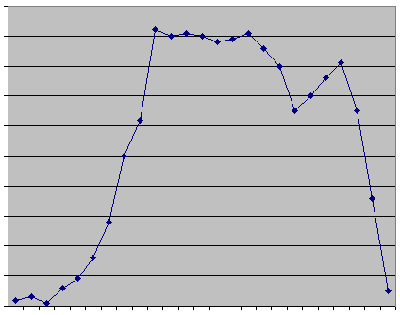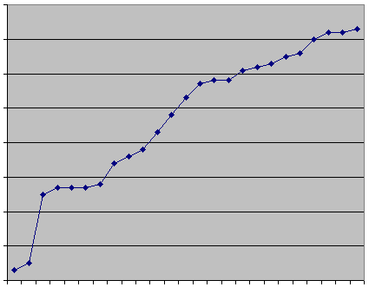

Each of the four labels below matches one of the graphs. In your group decide which is the most appropriate and why.

Water collecting in a rain gauge over 24 hours

Temperature in classroom throughout the day

Vehicles passing over Humber Bridge in 24 hours

Cars in town centre car park over a day

Describe in the box below what may be happening over the course of the day in the graph showing changes to a classroom temperature.

