
Flood Alert activity sheet – Pie charts Name: ……………………………… Date: …………………………….
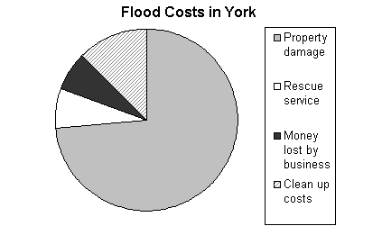
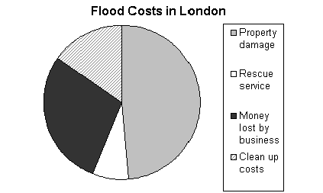
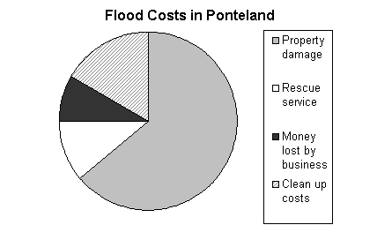

Total costs £48 500 000
Total costs £310 000 000
Total costs £4 700 000

Using the pie charts above, answer the following questions.

- Estimate the percentage of York’s flood cost that is property damage.

- Estimate the percentage of London’s flood cost spent on rescue services.

- Estimate the percentage of Ponteland’s flood cost spent on clean up.

- Which of the three places spent the highest percentage of it’s total on rescue services?

- Which place spent the most on rescue services?

6. Can you estimate the amount of property damage in York?

7. How much money was lost by business in London?

8. How much did it cost to clean up Ponteland?

9. The London Chamber of Commerce stated “London business lost more money through flooding than York or Ponteland lost in total.” Is this true or false?

10. From the pie charts it look as though York spent the same on rescue services as Ponteland spent on property damage. Is this true or false?

