Flood Alert Simulation –
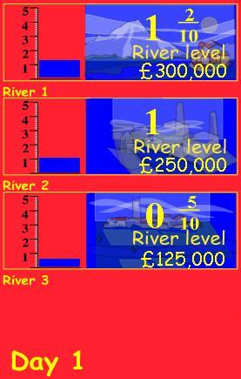

Worked example

On Day 1 of the simulation, river levels in 3
locations are beginning to rise after periods of
heavy rain.
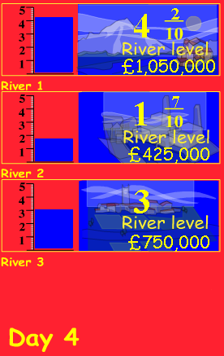

By Day 4, River 1 has reached crisis levels. Action needs to be taken.


We need to select emergency services before clicking


This succeeds in holding the river level until on Day 6 the days of sunshine are forecast to bring about the snowmelt.

A full Flood Alert is necessary to prevent catastrophe.
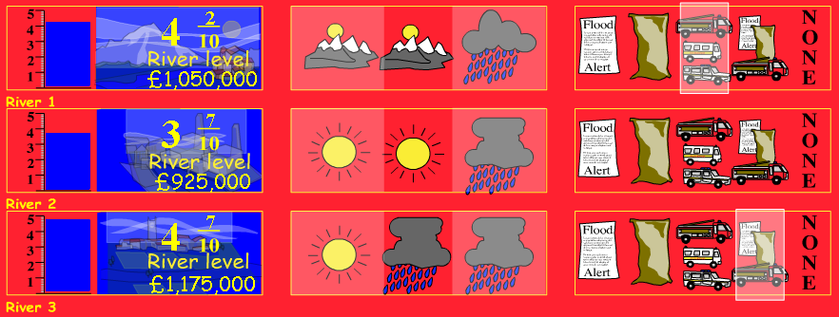
The situation is getting desperate as levels on rivers 2 and 3 continue to rise.

Half of the total budget has now been spent on the emergency.

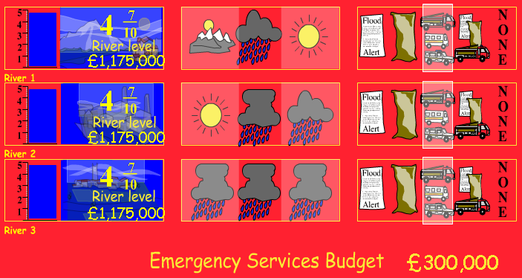
The situation reaches crisis point at all three river locations. With budget tight what actions are possible?
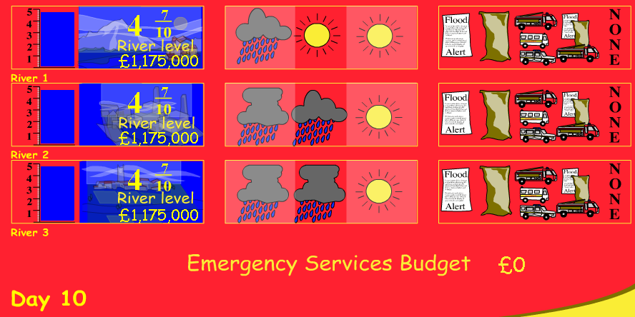

It takes every penny of the Emergency Services budget to keep the rivers levels under control.

